|  |  |
| --- | --- |
| **Practicum Case** |  |
| COMP6708  Object Oriented Programming |
| **Computer Science** | **O221-COMP6708-AS01-05** |
| ***Valid on*** *Odd Semester Year 2021/2022* | **Revision 00** |

## Learning Outcomes

* The additional features of OOP
* A program using additional features of OOP

## Topic

* Class Relationship

## Subtopics

* Composition
* Aggregation
* Association

## Soal

*Case*

**Ristorante Gustoso**

**Ristorante Gustoso** is a **restaurant** with Italian cuisine. To manage their **customers**, **reviews,** and **menus** list, they ask you to make a program to help them manage the list using **Java programming language** with Object-Oriented Programming concepts such as **Association, Composition and Aggregation**.

**Association** is relation between two classes. Association can be **one-to-one**, **one-to-many**, **many-to-one**, **many-to-many**. In Object-Oriented Programming, an Object can be related to the other Object to use the functionality provided. **Composition** and **Aggregation** are the two forms of association.

* The program will consist of **4 menus**:

1. View all restaurant data.
2. Input new customer.
3. Input rates
4. Exit

* If the user input 1, then:
* This menu will ask the user to input which restaurant data they want to view; it will consist of 4 menus:

1. View menus

2. View customers

3. View ratings

4. Back

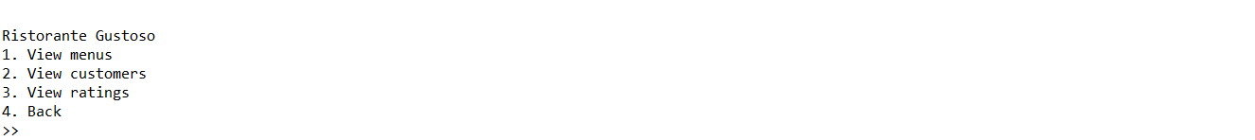

* If the user input 1, then:
* The program will show you a list of menus of Ristorante Gustoso. To go back to previous menu, you can press enter.

* If the user input 2, then:
* If there is no customer, then the program will display **No data**, otherwise the program will show you a list of customers of Ristorante Gustoso. To go back to previous menu, you can press enter.





* If the user input 3, then:
* If there is no rating, then the program will display **No data**, otherwise the program will show you a list of ratings of Ristorante Gustoso. To go back to previous menu, you can press enter.





* If the user input 4, then the program will back to main menu.
* If the user input 2, then:
* This menu will ask the user to input the customer’s data that comes to Ristorante Gustoso, the user needs to input the following information’s:
* Name of the customer

Validate the name of the customer must not be empty.

* Gender of the customer

Validate the gender of the customer must be either male / female (case insensitive).

* If the user input 3, then:
* This menu will ask the user to input the review’s data for Ristorante Gustoso, the user needs to input the following information’s:
* Rate for the restaurant

Validate the rate of the restaurant must be between 1 to 10.

* Comment for the restaurant

Validate the comment for the restaurant must not be empty.

* If the user input 4, then the program will be closed.

**Please ask your teaching assistant if there are any related questions.**